# Overview

* Decision making and a series of tasks combine to form an intricate system of farming
* Multitude of factors ranging from seasons to seed quality to steps taken will affect the yield quality

# Farming System

* Buying the seeds : Seeds can either be bought from the store, from other players or can be collected from the harvest itself. But doing so will decrease the yield.
* Choosing the crop : once the players choose the crop, the system will inform them the prerequisite needed for that particular crop. Each crop has its own prerequisites.
* Seasons: some crops are seasonal and cannot be grown otherwise
* The farming system include the following steps
  + Preparing the land : The farm must be prepared for the land chosen. Eg how deep and fine it must be tilled may differ for each crop. The resulting time required for the same may vary.
  + Augmenting the fertility : some crops may benefit from augmenting the fertility
  + Sowing of seed : various methods are available to the player for sowing seeds. The player can take that decision based on the time taken and cost of the method.
  + Irrigation and fertilization : Proper irrigation and fertilization will lead to greater quality and quantity of yield. Overdoing or undergoing these will lead to adverse effect.
  + Maintenance : Protecting from pests and viruses.
  + Harvesting : again, various methods are available to the player. The player can take that decision based on the time taken and cost of the method.
* The player will start with basic methods. Advanced methods can be researched/bought using diamonds.
* The player will use the farming panel, by clicking on the crops icon, for these tasks

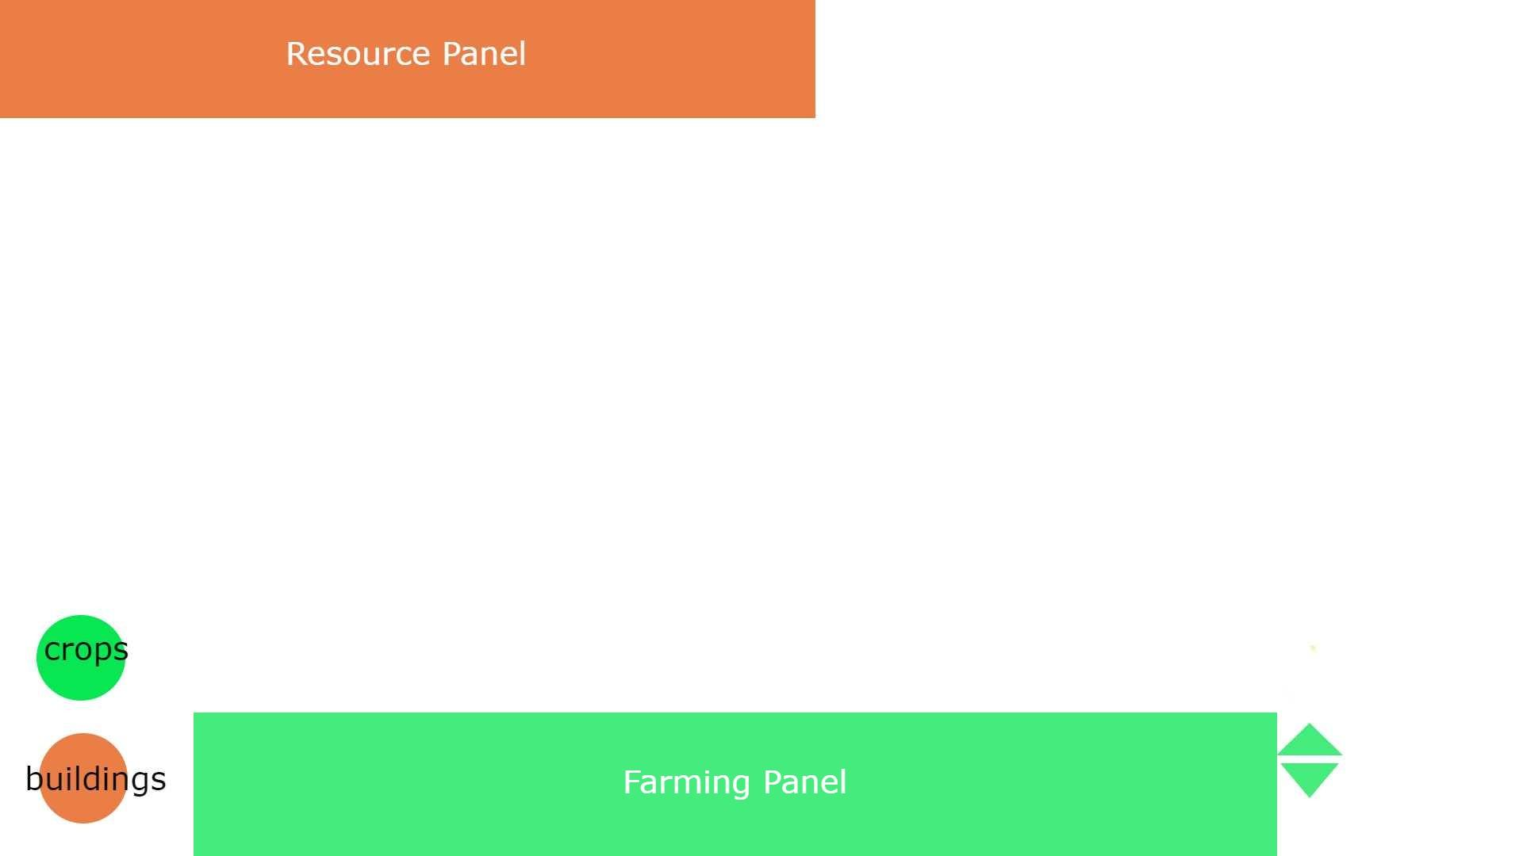

* The player will select the task that they want to perform.
* Selecting the task will give them the various options of methods available to them.
* After selecting the method, the cursor will change to an icon of the method selected. Then the player will click on the farm unit that they want to perform these tasks on.

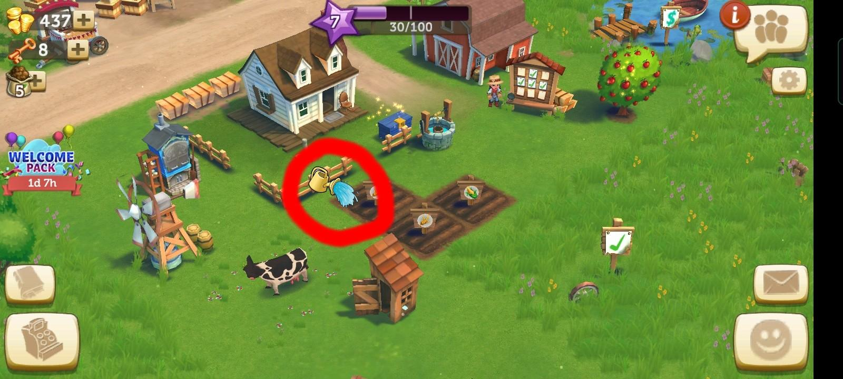

* The player can add up to 2 tasks to their queue. This queue can be upgraded twice to add up to 6 tasks
* Time taken for each task/method can also be upgraded.

# Exposed Variables

* Duration for each method per task
* Cost of each method per task
* Fertilization augmentation rate
* Yield factor for each method per task